## **Description: Description: Vertical full colour positiveYear 12 General Biology**

## **Task 1 – Asexual reproductions in plants**

|  |  |  |  |
| --- | --- | --- | --- |
| **Name:** | **Teacher:** | **Date:** | **Mark:**  **Part A: / 28**  **Part B: / 16**  **Total: / 44** |

**Assessment type:** Science Inquiry - Practical

**Conditions**

Time for the task:

* **Part A- practical investigation and data collection- completed in class and data collected for a duration of 2 weeks.**
* **Part B- completed in class under supervised conditions.**

**Task weighting** – 10%

___________________________________________________________________________

**Introduction**

Vegetative propagation is one form of asexual reproduction – the production of offspring involving one parent only. There is no fusion of gametes and the offspring are genetically identical to the parents; they are clones.

This kind of reproduction is common in plants. It occurs in a variety of ways, depending on the tissue from which the new plant material originates. Horticulturalists and gardeners make use of vegetative reproduction in commercial plant propagation. It is often used in preference to sexual reproduction (where plants are allowed to flower and produce seeds and new plants are grown from these seeds). In many cases, vegetative reproduction is the only kind of reproduction used in the mass production of plant.

**Purpose**

1. To grow plant material using different methods of asexual reproduction.
2. To observe and monitor the development of new plant growth.
3. To consider the commercial applications of knowledge of asexual reproduction in plants.

Instructions:

1. Complete all **two** parts to this assessment item.
2. Section 1 is a practical activity; Section 2 is short answer discussion questions done in class under supervised conditions.
3. You will be given in-class time for Section 2.
4. You must make 6 observational recording of your plants. These must occur periodically over a 3-week time frame.

**Section 1: Part A**

**Growth from a cutting**

**Materials**

* Ivy plant
* White tile
* Scalpel
* Beaker or Jar of water
* Ruler (mm)
* Carboard disc

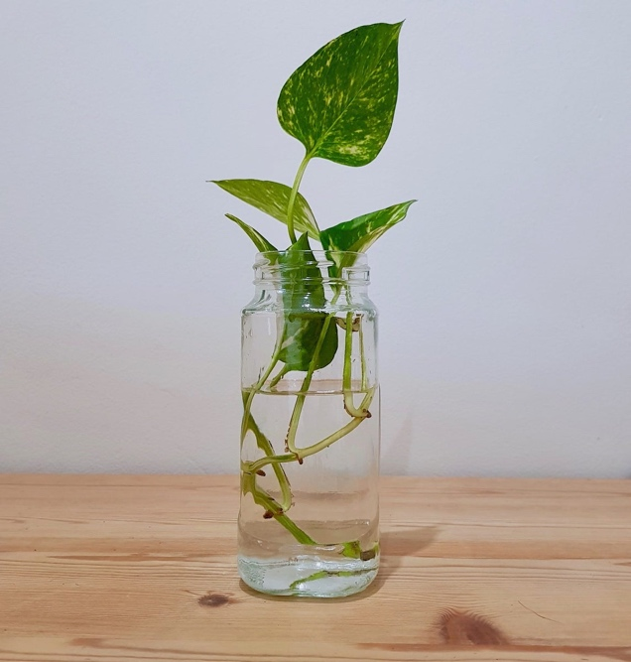

**Procedure**

1. Choose a piece of stem with leaves but no flowers. Place a section of your fresh plant material on a white tile. Use the scalpel to make a clean cut through the stem 8 – 10cm from the tip.
2. Strip the stem of all but the top four leaves.
3. Use the scalpel carefully to make a small cut in the stem tissue within 1cm of its base.
4. Fill the beaker to three-full.
5. Secure your cutting so that it is suspended in the water without touching the bottom. A simple way to do this is to cut a circular piece of cardboard with a larger diameter than the top of the beaker you are using. Then, cut a small hole in centre of the disc. Push the cutting through the centre and place it over the mouth of your beaker.
6. Place your preparation on a bench near a window for suitable light exposure.

**Results**

Instructions:

1. Observe your cutting every few days, keeping a record of the changes you notice. Your observations should include a measurement of the length of your cutting, the numbers of leaves, the colour, the root development and any other features you notice.
2. Record your results in your table on the following page. Include in your table name of species and all relevant data.

Title:______________________________________________________

|  |  |  |
| --- | --- | --- |
| **Date** | **Scientific Diagram** | **Observation** |
|  |  |  |
|  |  |  |
|  |  |  |
|  |  |  |
|  |  |  |
|  |  |  |

**Section 1: Part B**

**Growth from a leaf**

**Materials**

* Succulent leaves
* Beaker
* Water
* Root growth hormone

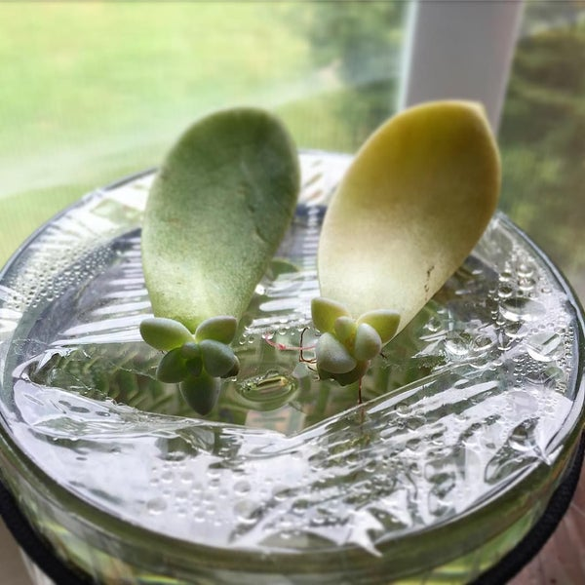

**Procedure**

1. Remove the succulent leaf from the cutting and ensure dry.
2. Select a beaker and half fill with water and root growth hormone.
3. Place the leaf upright into the beaker, ensuring only half of leaf is submerged.
4. Place the preparation on a bench near a window.
5. Check every few days to ensure that the preparation does not dry out. If water is required, add enough to keep the leaf submerged.

**Results**

1. Check the succulent leaf every few days, recording any observations you make. Include the day and date, a diagram showing any change and a description of your observations.
2. Use a ruler to measure the size of any new growth you notice. Record your measurements under ‘observations’ in your table.
3. Record your results in table. Include in your table title, name of species and all relevant data.

Title:______________________________________________________

|  |  |  |
| --- | --- | --- |
| **Date** | **Scientific Diagram** | **Observation** |
|  |  |  |
|  |  |  |
|  |  |  |
|  |  |  |
|  |  |  |
|  |  |  |

**Section 1: Part C**

**Growth from a Bulb**

Materials

* Garlic
* Beaker or jar of water
* Toothpicks or skewer

Procedure

1. Choose a garlic clove cleaned from its skin.
2. Fill a beaker to approximately three-quarters full.
3. Use toothpicks or skewers to suspend the garlic over the top of the beaker so that some of the eyes are immersed in the water.
4. Place the beaker and the garlic on a bench near a window.

Results

1. Check the garlic every few days, recording any observations you make. Include the day and date, a diagram showing any change and a description of your observations. Use a ruler to measure the length of new growth you notice.
2. Record your results in your table. Include in your table title, name of species and all relevant data.

Title:______________________________________________________

|  |  |  |
| --- | --- | --- |
| **Date** | **Scientific Diagram** | **Observation** |
|  |  |  |
|  |  |  |
|  |  |  |
|  |  |  |
|  |  |  |
|  |  |  |

**Part D - Line Graph**

Title:_________________________________________

**Section 1 Marking Rubric:**

|  |  |
| --- | --- |
| **Part A - Results Table 1** | **Mark** |
| Table includes correct title. | 1 |
| Biological drawings include detailedinformation and to scale. 1 for each of the 6 observations. | 3 |
| Writes observations in detail with explicit data, 1 for each of the 6 observations. | 3 |
| **Part B - Results Table 2** | **Mark** |
| Table includes correct title. | 1 |
| Biological drawings include detailedinformation and to scale. 1 for each of the 6 observations. | 3 |
| Writes observations in detail with explicit data, 1 for each of the 6 observations. | 3 |
| **Part C - Results Table 3** | **Mark** |
| Table includes correct title. | 1 |
| Biological drawings include detailedinformation and to scale. 1 for each of the 6 observations. | 3 |
| Writes observations in detail with explicit data, 1 for each of the 6 observations. | 3 |
| **Part D – Line Graph** | **Mark** |
| Graph title (Includes both variables tested) | 1 |
| Axis title (0.5 mark each axis title). | 1 |
| Axis indices (0.5 mark each axis). | 1 |
| Line graph for each growth (1 mark per line). | 3 |
| Scale (accurate and consistent) | 1 |
| **Total Marks** | **/28** |